PowerConnections
5 Harold Close, The Pinnacles, Harlow Essex CM19 5TH
Tel: +44 (0) 1279 422 022; Fax: +44 (0) 1279 626 304

Declaration of Conformity

(CE Certificate)

Ref. No. CP3
We PowerConnections
Of 5 Harold Close, The Pinnacles, Harlow, Essex, CM19 5TH, UK.

Declare under our sole responsibility that product Australian Converter Plug type CP3 to which this declaration relates is in conformity with the technical requirements of the following standard(s):

STANDARD CLAUSES

AS/NZS 3112:2004 + Amdt 1 Full type test

OTRSA Licence No 10997

The above tests are carried out by International Testing and Certification Services Pty. Ltd. 4 - 6 Second Street, Bowden SA 5007; the complete type test is carried out as specified in the UL schedule for type testing and approval

Also the above product is in accordance and compliance with the requirements of the Low Voltage Directive 73/73EEC, and RoHS & REACH requirements

Authorized By: 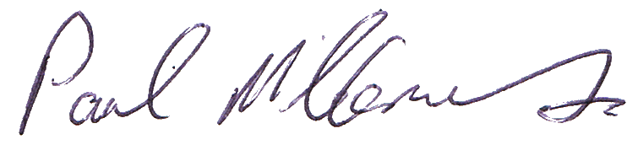
Paul McClements
Title Quality and Certification Manager
Date of Issue 4th March 2015

- Note: All test reports, compliance documents are available on request

